ADMIN STUDENT SET UP GUIDE: EFFECTIVE June 9, 2015

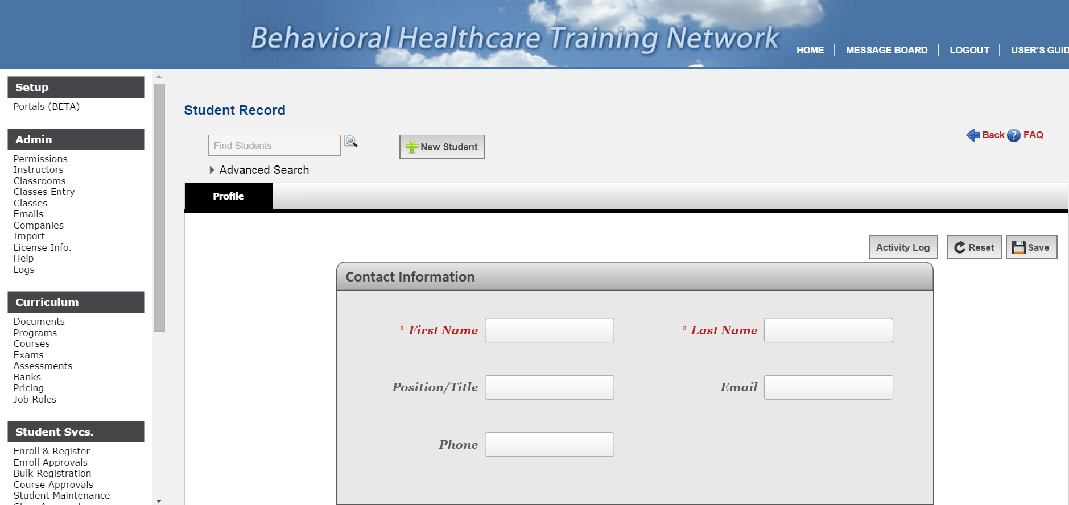
- SEARCH for your student to make sure they do not have an old account.
- If not in system select +NEW STUDENT
- Add students F/L name, email, position

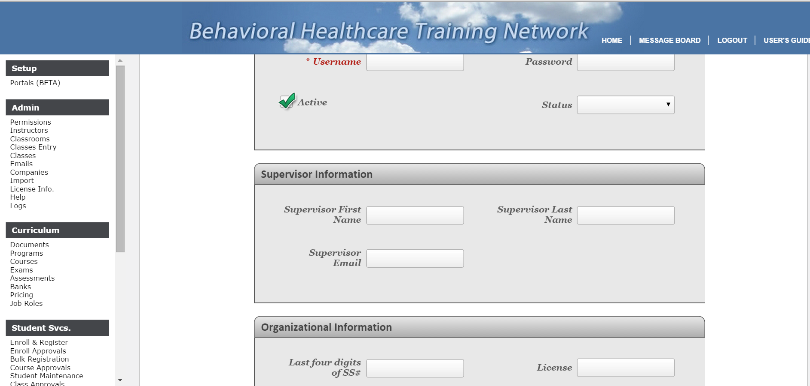
- Add student USERNAME/PASSWORD. No requirements on set up.
- Check ACTIVE box and change STATUS to ACTIVE
- Add supervisor information
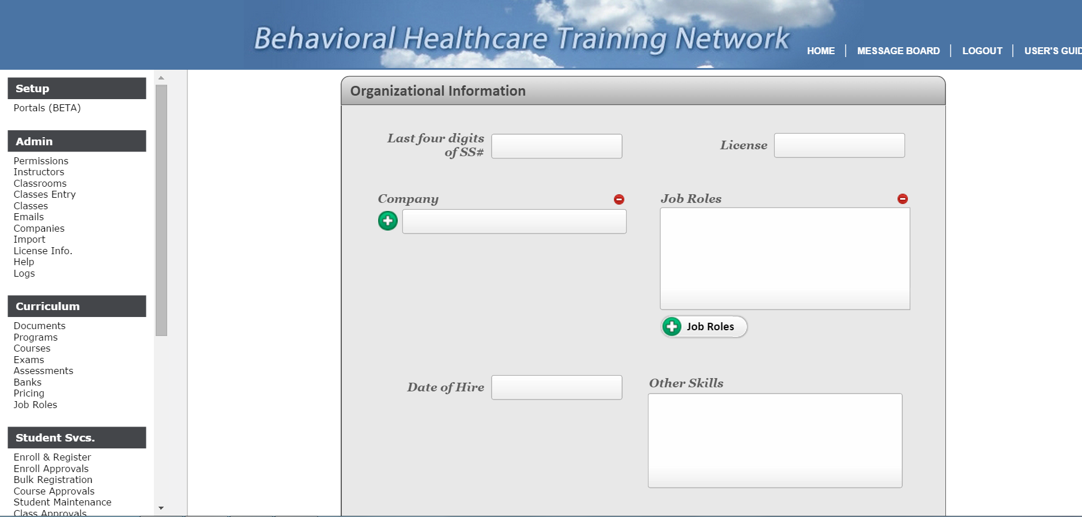
- Add last four digits of SS#(for second level identifier)
- Add License # for CEU’s
- Select your company
- Select the appropriate JOB ROLE for the student (Please review the Job Role Set Up) document located in your admin document library prior to doing this.
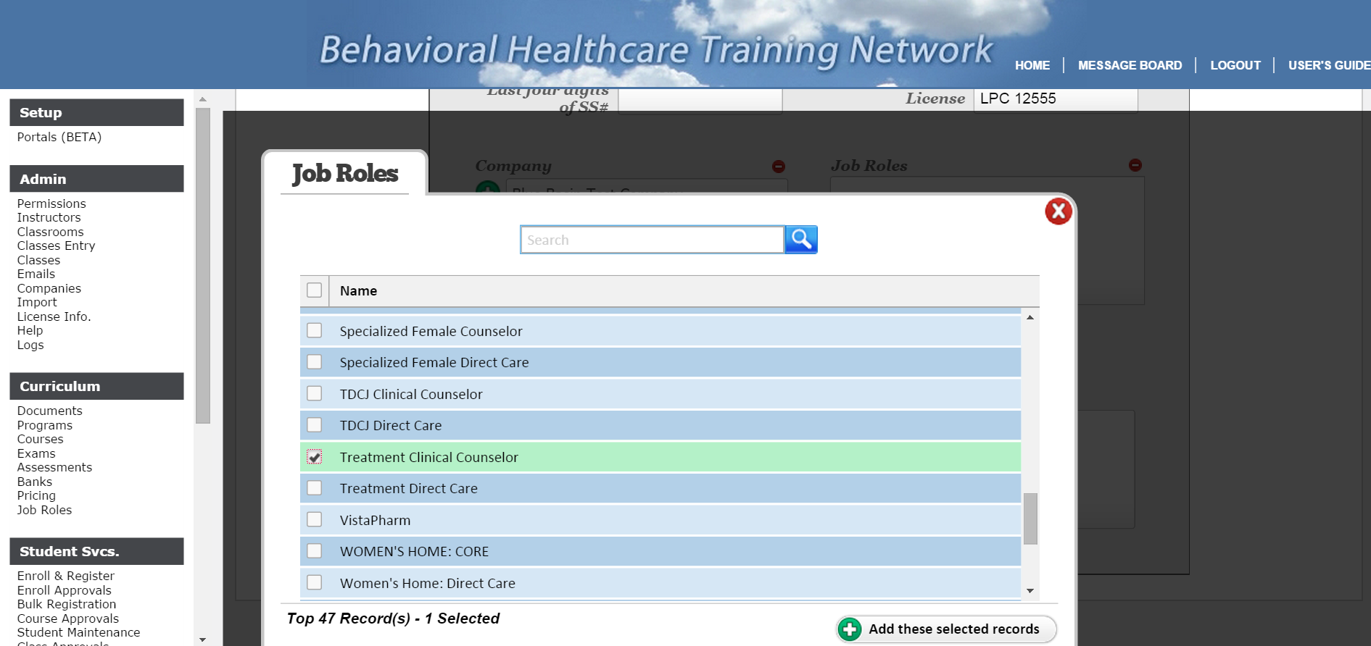
**It is extremely important that you select the correct job role for your student. This drives what trainings they will be required to take. All students should only have ONE JOB ROLE!!!! If you would like to know what courses fall under the JOB ROLES then you can go to your Documents link and look for the Current List of Training Programs and Course Content Within Document. This will give you an idea of what is under each job role.
- Once you have completed the first page (Profile page) hit SAVE at the top right of page.

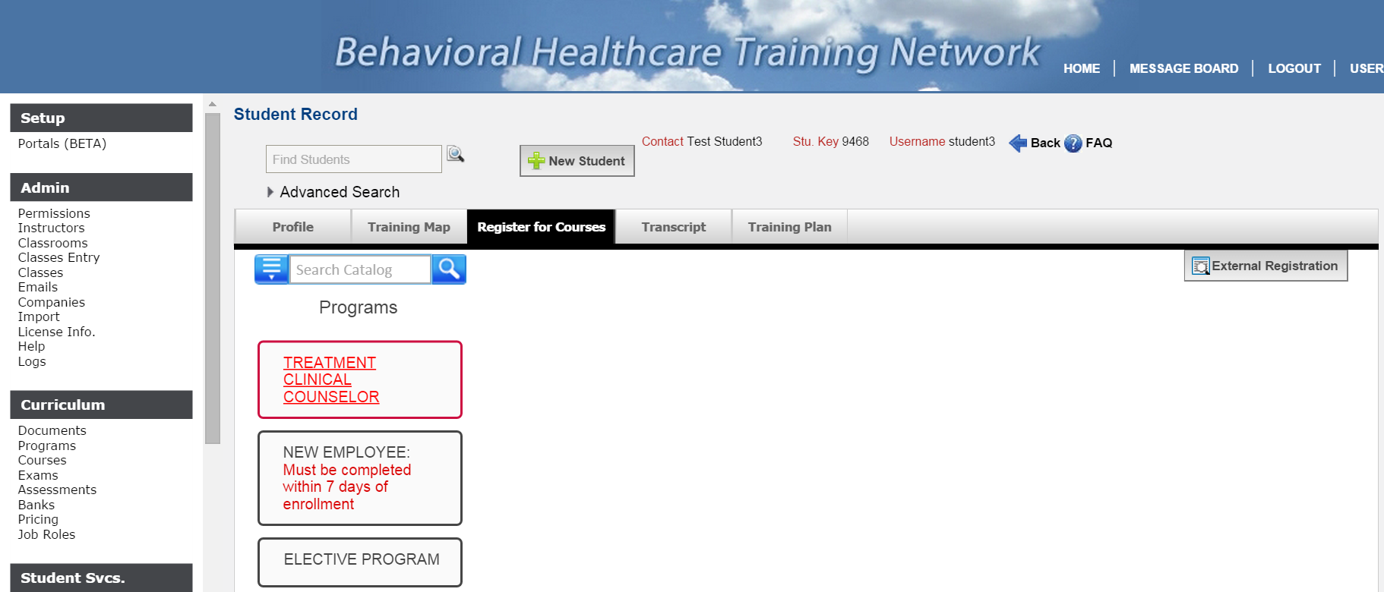
- Now you go to the “REGISTER FOR COURSES” tab.
- Here you will see the corresponding training programs based on your job role selection.
- You can view this window a multitude of ways (IT IS SET TO SHOW YOU ACTIVE ONLY). See the small window below for other options.

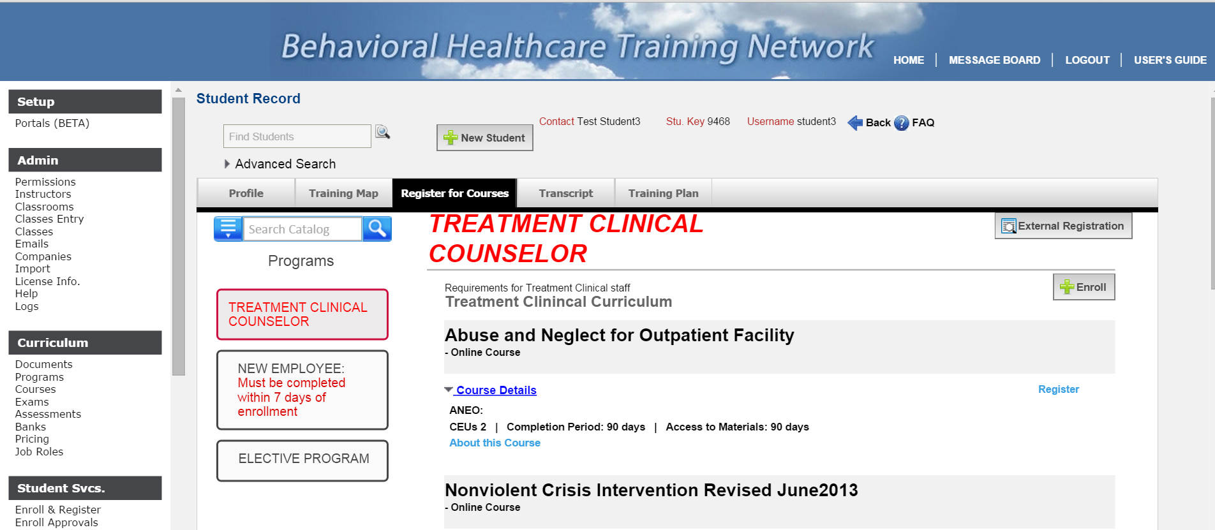
- You will need to Enroll your students into each training program in the list. This allows them to take the courses under each program.
- Click on the PROGRAM. The ENROLL button appears. Select it. The screen below appears.
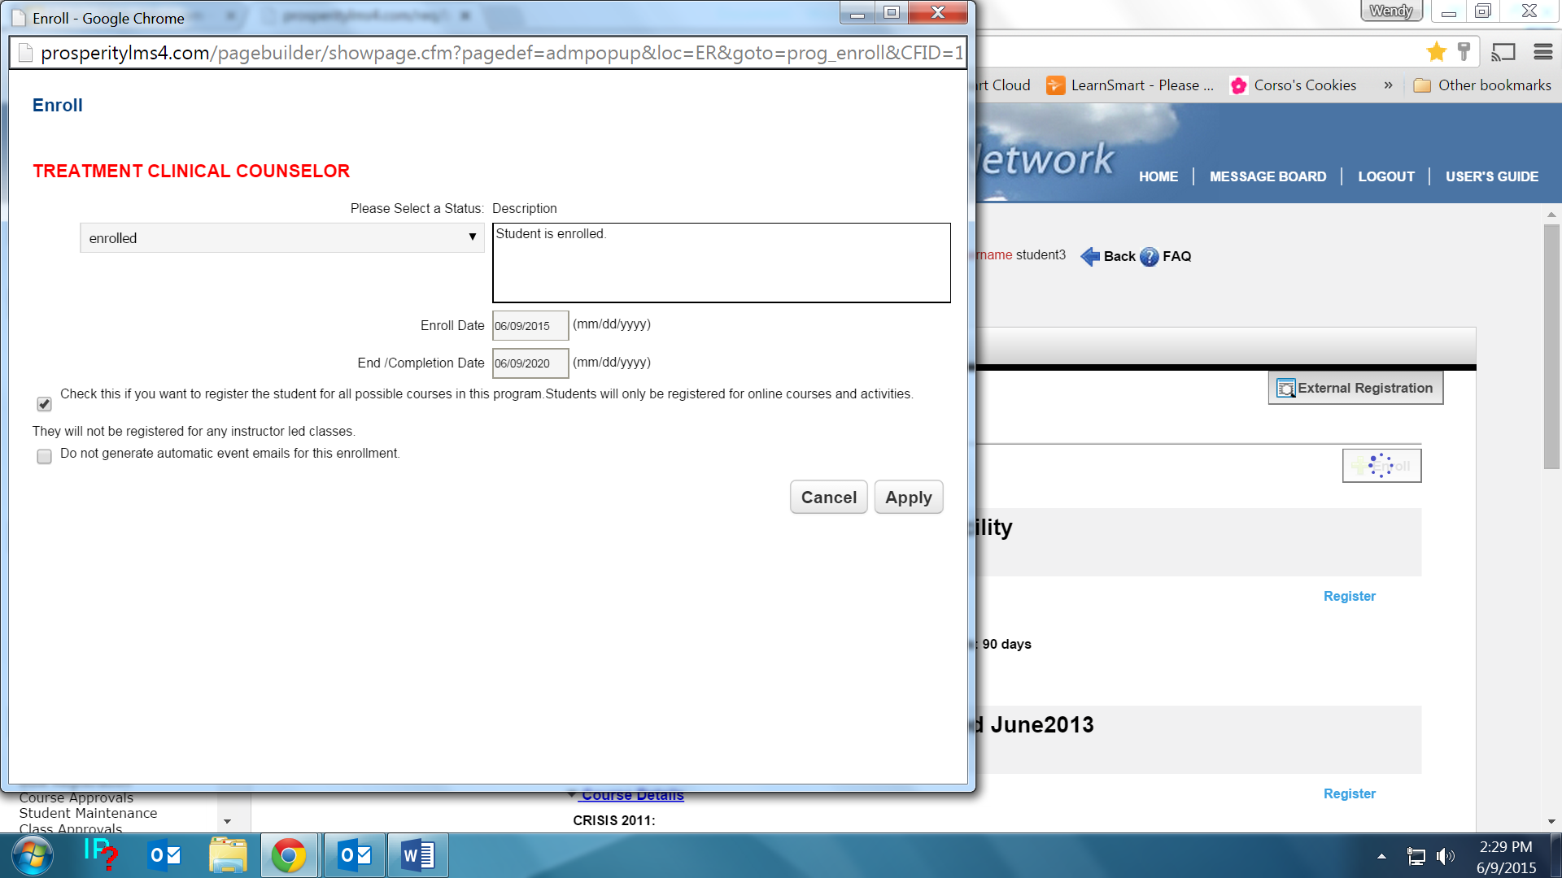
- If you want to go ahead and enroll them in the courses under that program, place a check on the first “CHECK THIS” item than “APPLY”. If not (usually you leave this unchecked for the ELECTIVE program) then leave it unchecked.
- Do this for each program in their list (should only be 3)
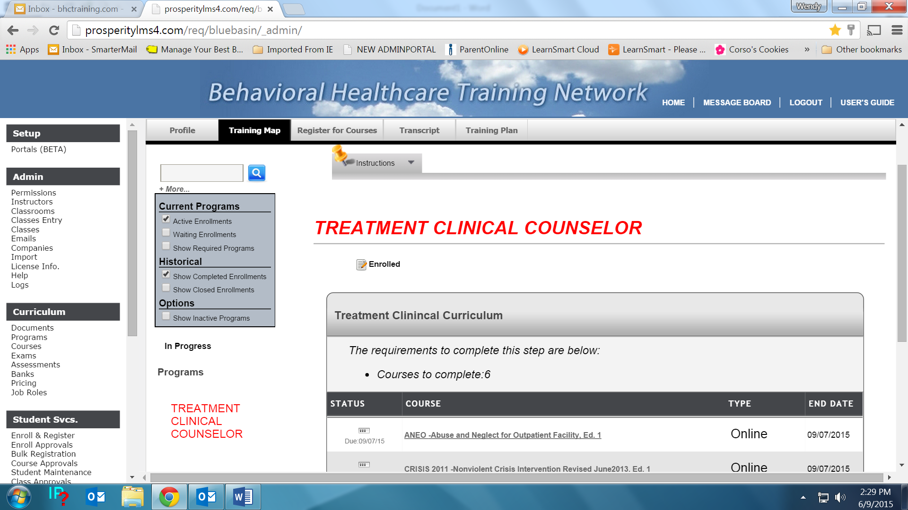
- Once the PROGRAMS are enrolled in, the courses that are currently open drop to the “TRAINING MAP” This is the equivalent on the student pages as their “COURSES”. It is simply the spot to show you what they currently have opened and is in process of completing.
- You also have the option to view this window several ways. It is defaulted to show you ACTIVE Enrollments. (This area will be upgraded soon to match the other windows)
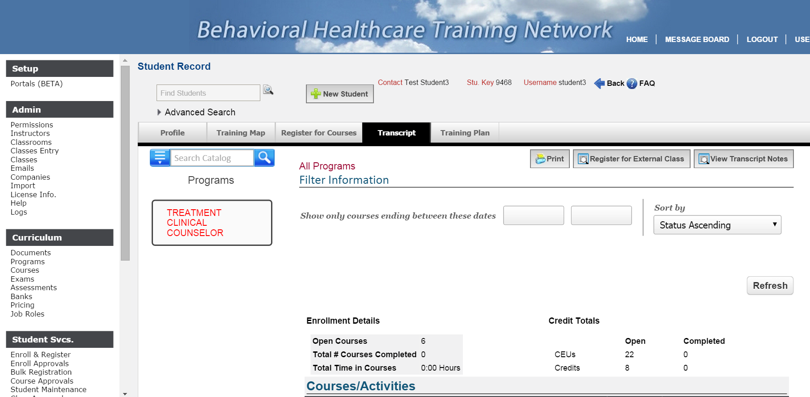
- You can see the student’s course history by viewing their Transcript.
- You can view this page several ways (see box below).
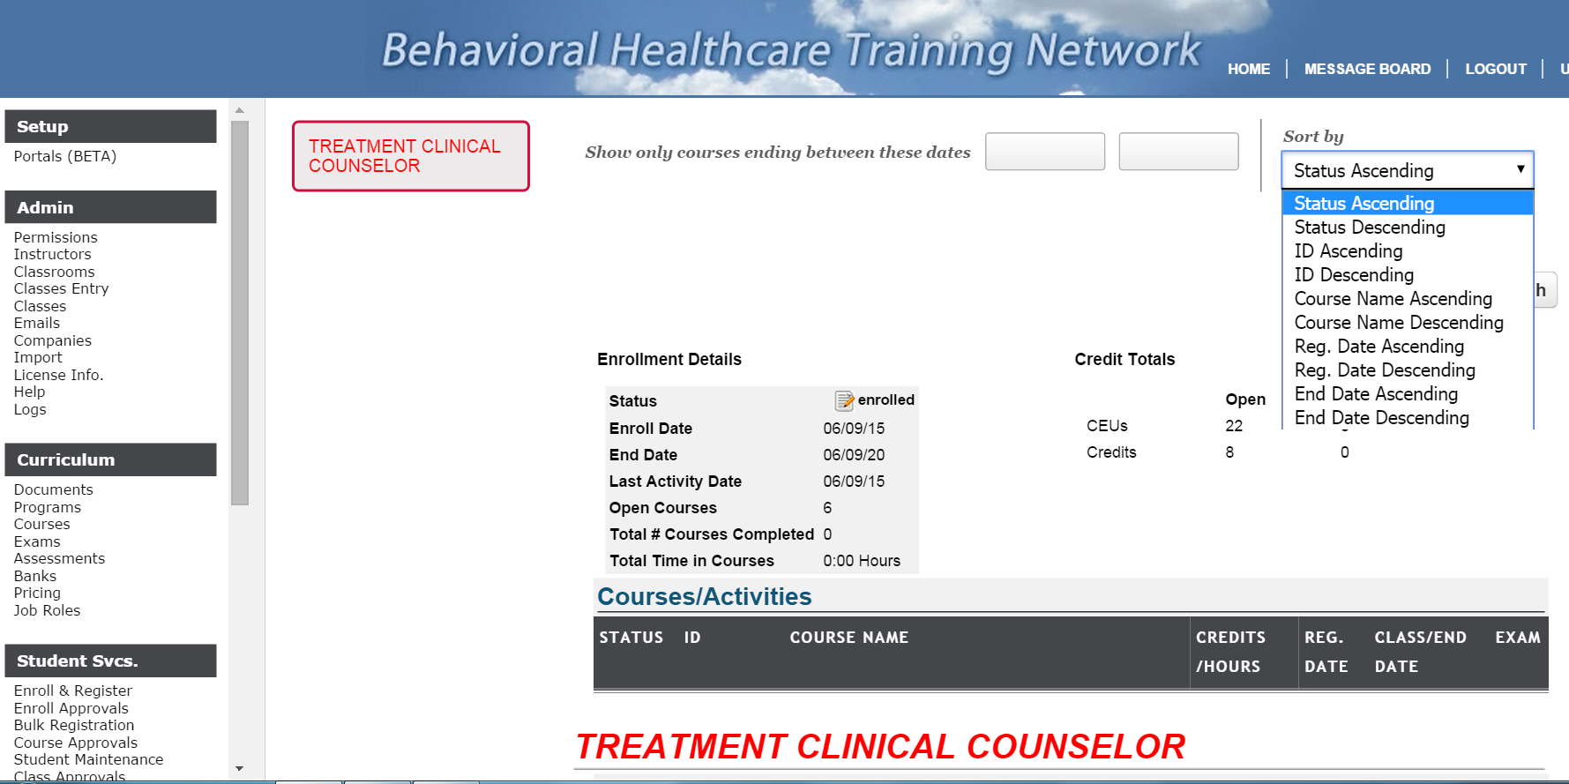
- You can view the transcript by Program only by selecting the Program.
- You can also view the transcript by any number of SORT BY options.
- 5. You can see the status of the program here.
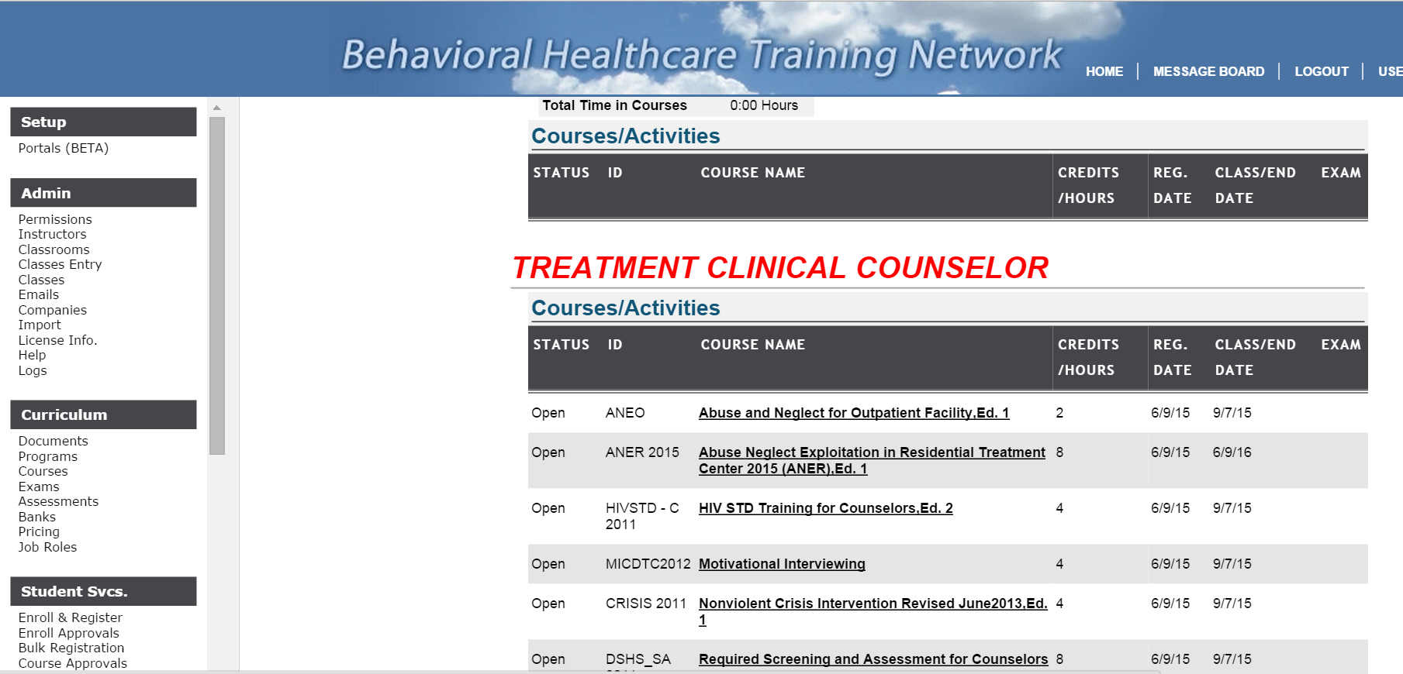
- You can look at the detail associated with each course by selecting the course on the Transcript.
- Once the course is complete, you will see the Certificate and Exam information and the OPEN will say COMPLETE.
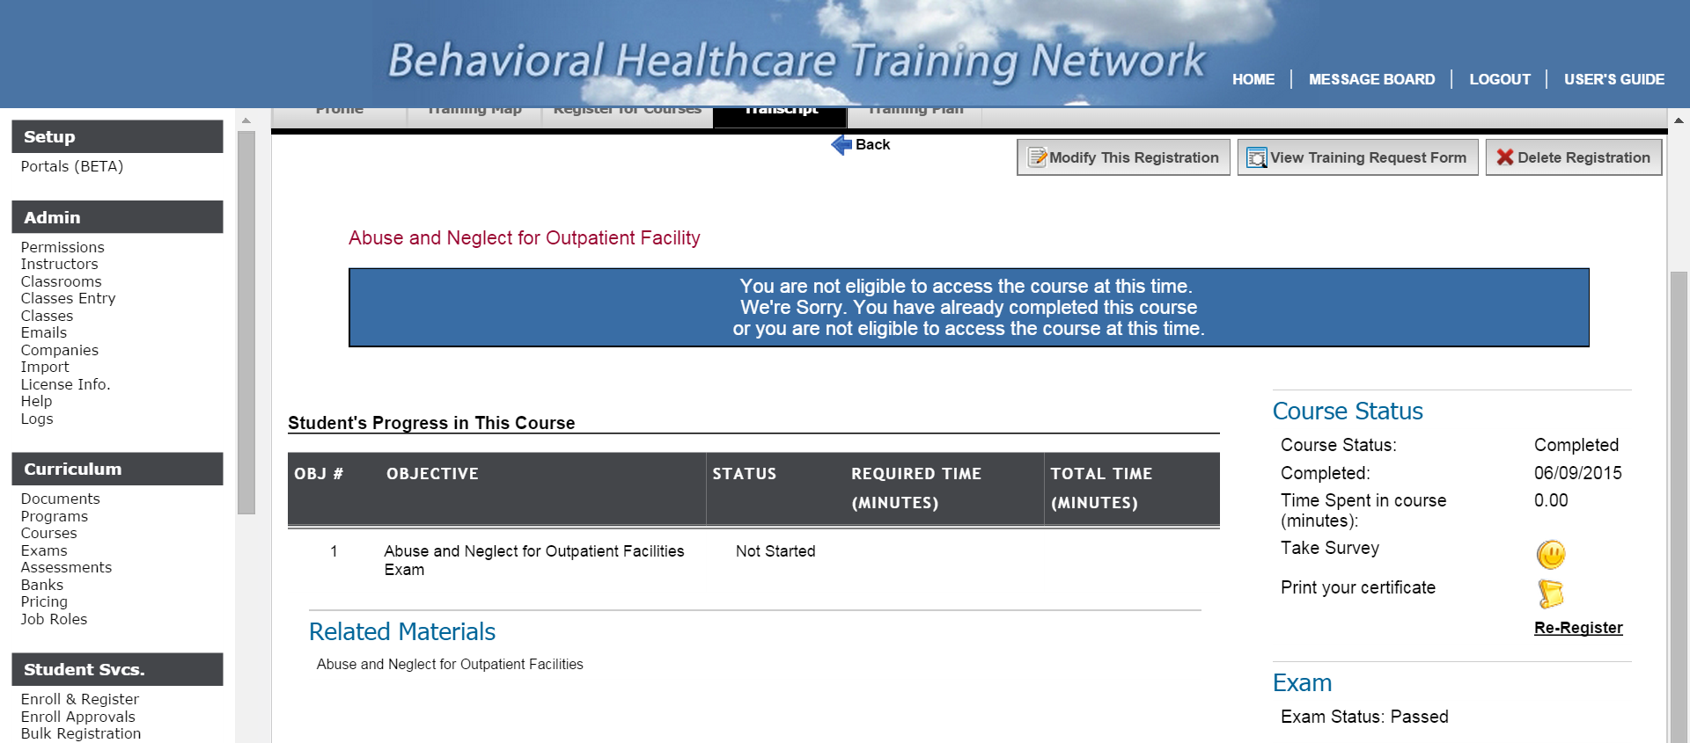
- This is the view once you select the course. You can see and Print the certificate. You can see how much time they spend on the course. You can see the Exam status.

