Training Plan Supervision Tool
This is a piece within the LMS that we created to allow you to require additional training of your students that may need some additional training requirements as part of Supervision documentation. You have the ability to assign additional trainings with a due date and a printed out document for signatures to your students.

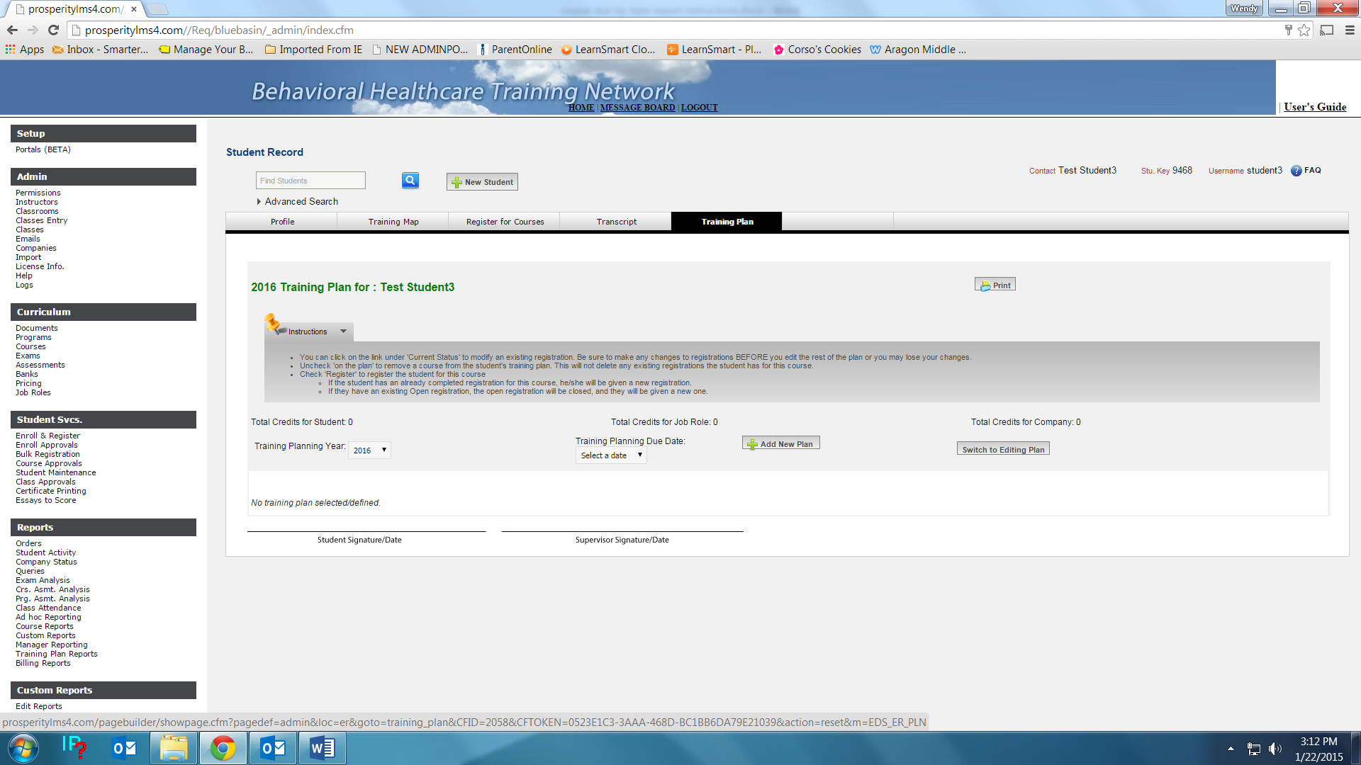
- Look up your student.
- On the students profile page select the tab labeled “Training Plan”
- Select the current year in the “Training Plan Year”
- Hit “ADD PLAN”
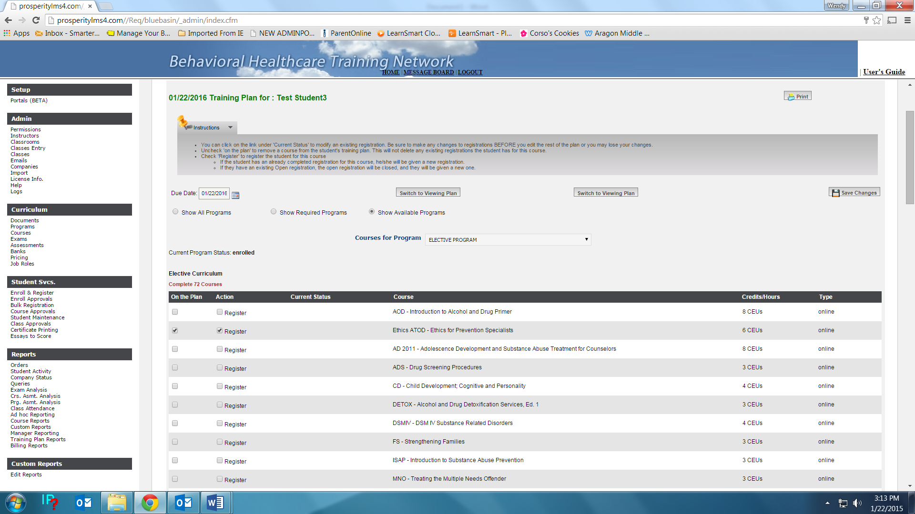
- Assign a due date.
- Under “Courses for Program” Select the ELECTIVE PROGRAM
- Once you do this, the screen displays all the courses in the Elective Program.
- Place a check in both the “ON PLAN” and the REGISTER boxes. Select Save Changes
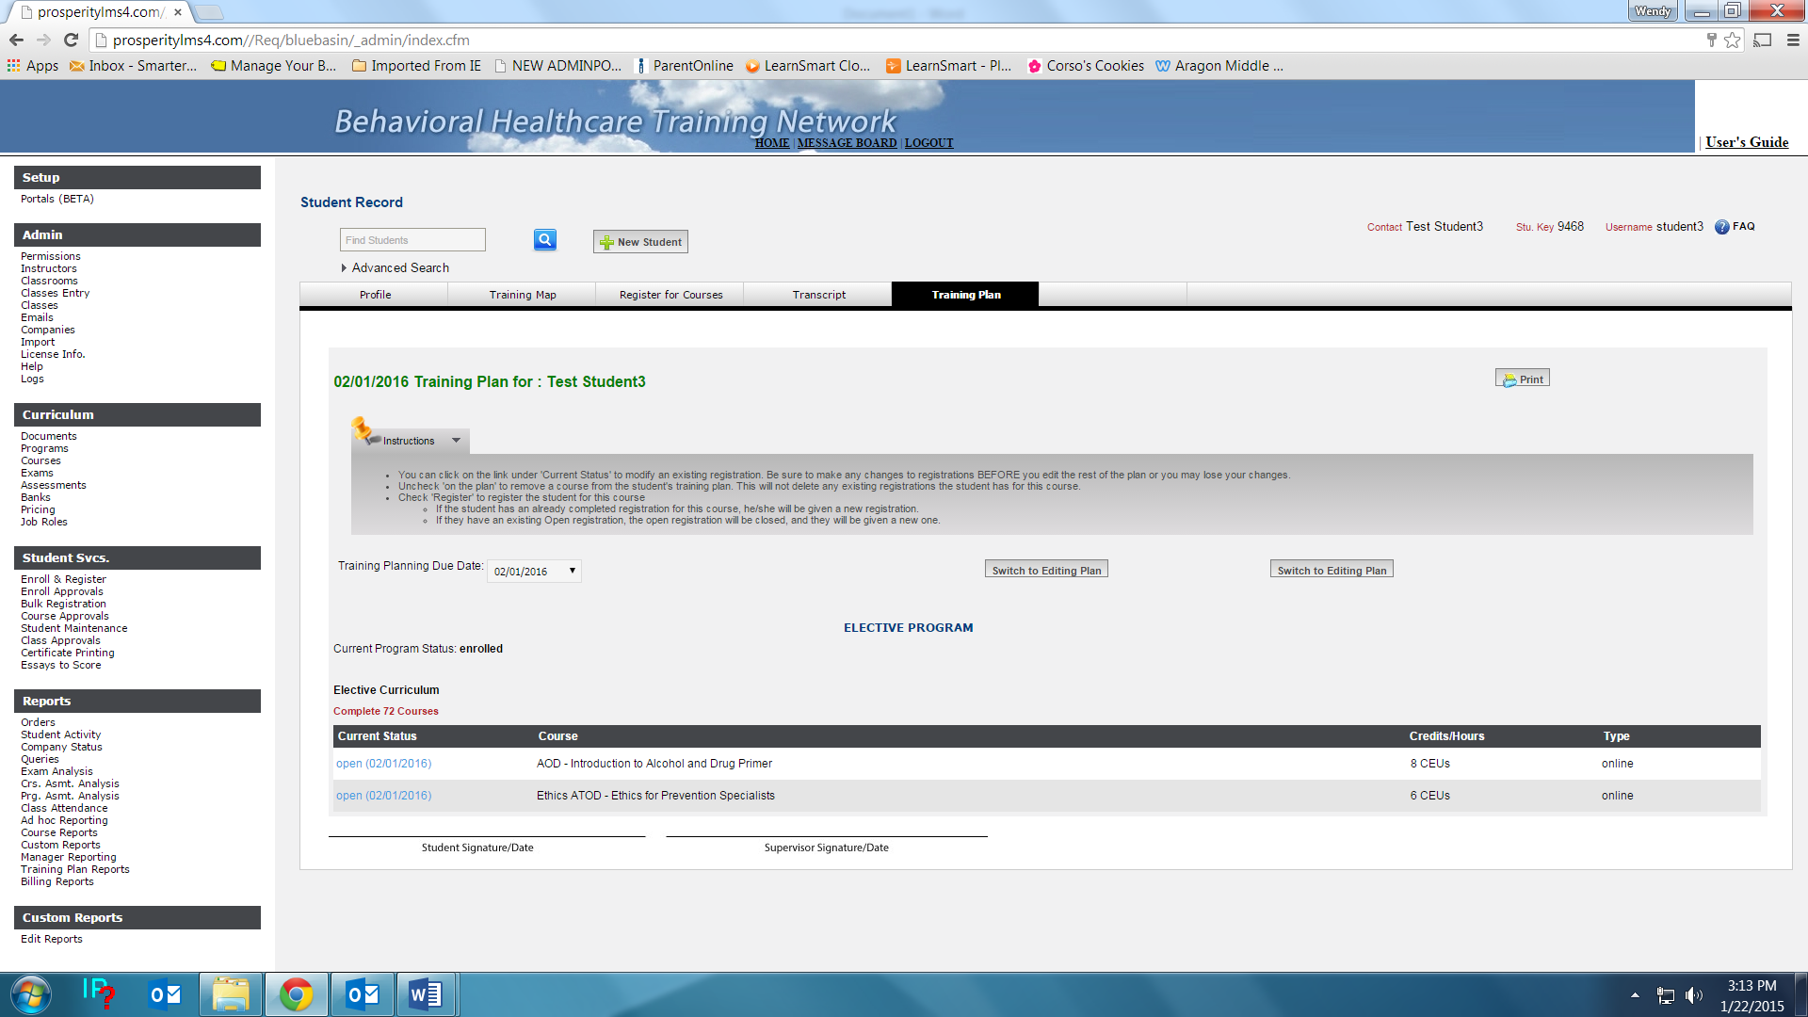
- Once you have saved it, it displays as above.
- You may hit PRINT and the document appears as the window below.
- If you need to edit the plan. You can select switch to editing plan button. This takes you back to the beginning. Repeat the course adding step and save.

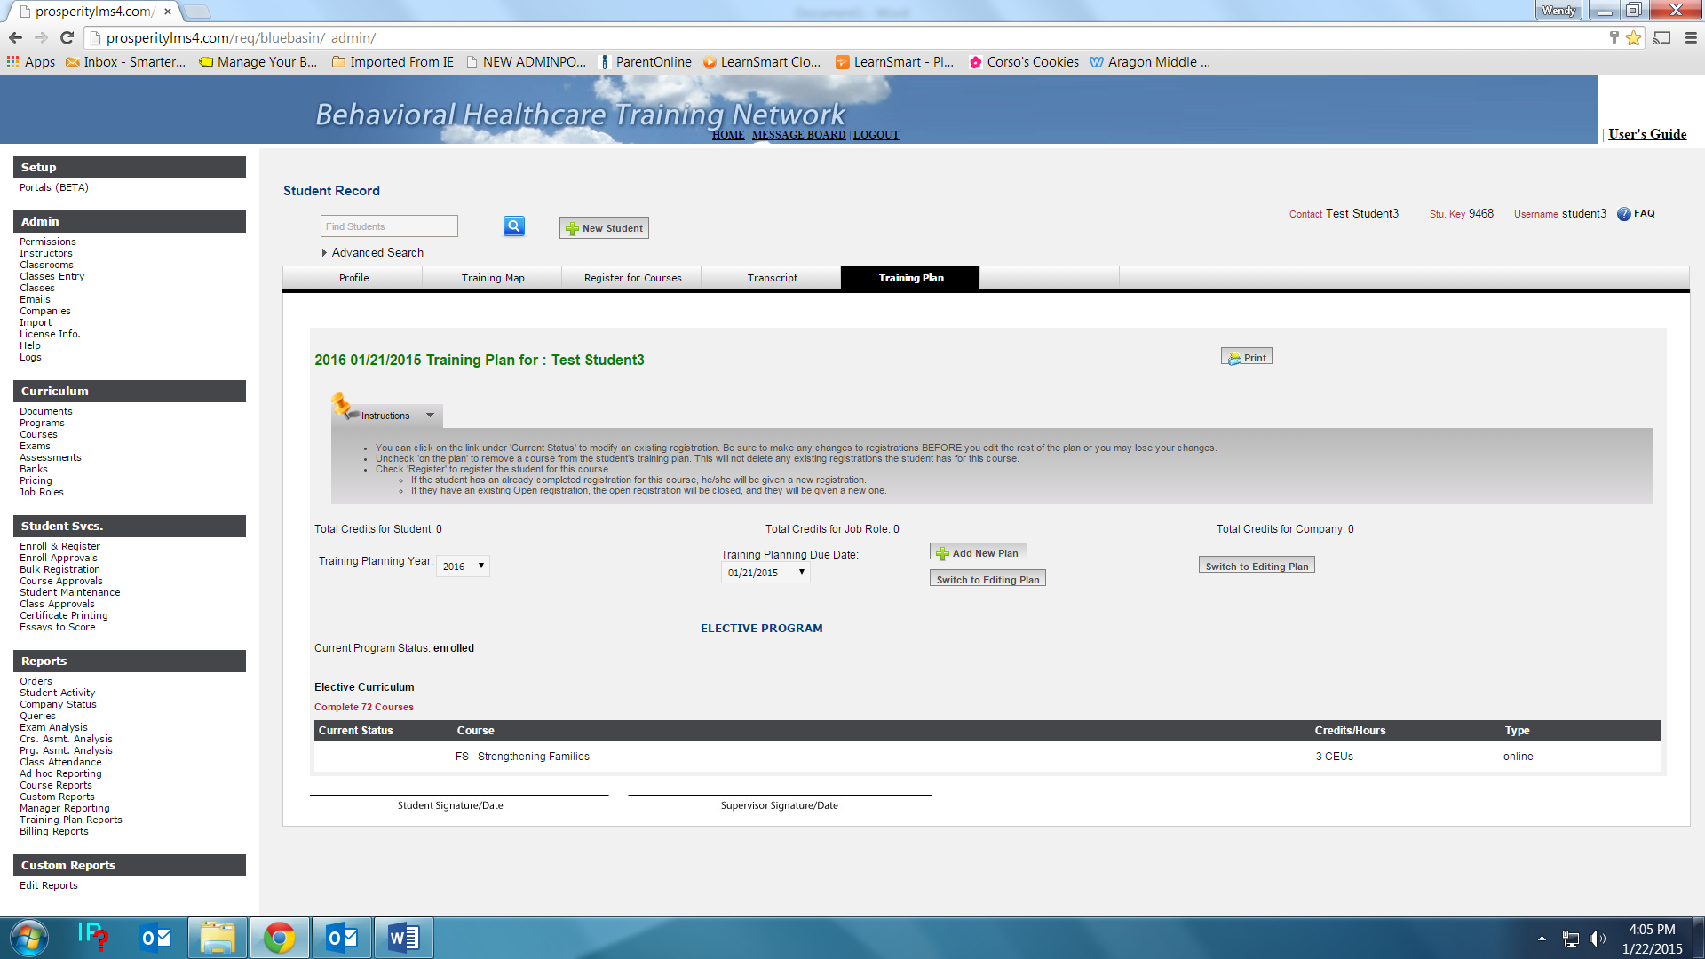
- You can look at old plans by selecting Training Plan Due Dates
- It will display all courses in that particular plan in the window.

